Project Design Phase-II
Data Flow Diagram & User Stories

Date | 26-11-2025
Name | Sathish kumar s
Project Name | DocSpot – Doctor Appointment Booking System
Maximum Marks | 4 Marks

Data Flow Diagrams:
A Data Flow Diagram (DFD) illustrates how data flows within the DocSpot platform. It captures how patients, doctors, and admins interact with the system, how appointment details move between components, and where the data is stored
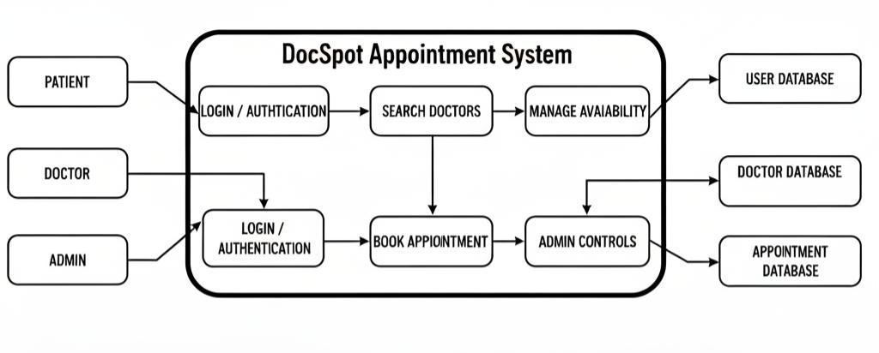
Example: DFD Level 0 (Industry Standard)

User Stories

User Story Table – DocSpot
